The Garden Post
Issue #190 June 2019
Co-Editors. Norma Stancati and Kathy Kienle
Environmental Denise Clegg
Horticulture Amy Nelson
Poetry Marilyn Hartley-Kik

During the winter, we have all had a chance to rest up and now have the energy to get into gear for our summer of gardening and special events. We are watching the return migration of birds and pollinators. I bet that they had a wonderful time wintering in the South, but I will also bet that we can provide them with a friendly environment here in Michigan. After all, we want those pollinators to get to work in our gardens. The cool spring does make me worry that our Mason bees may have a harder time getting started this year. Keep in mind that your gardens can also provide you with inspiration for awards available from MGC and Central Region. Working toward an award is not only a wonderful way to learn more about your plants but also to appreciate your gardens in a new and creative way.
Not only are our home gardens ready to be tilled, fertilized, and replanted but also those many community gardens that our members maintain are beginning to benefit from the skills and hard work of our many members. It makes one proud to be a part of the service and beautification that you provide to the Kalamazoo area. One must not forget our very own Council House grounds. With direction from your Council Board, Joann Wespinter has developed a map for each area of our grounds. Each club now has an area which they can maintain. It is hoped that this new structure will make it easier for us to have grounds that truly reflect our talents and love of plants and environment. Be sure to take time to sit in the butterfly garden letting it give you beauty and peacefulness. Thanks to Petal Pushers for taking on this project!
Looking back at event highlights, the Greens Sale was another success thanks to Brenda Carl and Sharon Eaton along with the many Committee Chairs and countless volunteers. Let’s make the 2019 Greens Sale another “Barn Burner” by each of us sharing our talents and time as we are able. Everyone should participate at some level as this is our biggest fundraiser of the year. In March, we hosted “Michigan Backroads.” Ron Rademacher provided an entertaining and educational presentation about the back roads of our beautiful state. He described road trips to unique destinations and unusual places. This event was also a successful fundraiser for our Council. More recently, Council hosted the new member brunch. Bunny LaDuke provided a slide show telling the story of our Council history. It was most informative and interesting. Also, the brunch was a wonderful opportunity to get to know new members from other clubs. A good way to start to feel at home. Hats off to all who made these events big successes!
A few words about the work that your Council Board is doing for you. They are working hard at establishing a Policy Manual, completing a review of our by-laws, and discussing the need of a mission statement. Your Board is hard at work and always remembers that their focus is to support the clubs that they represent.
I would leave you with this thought: Our gardens are our first impression. People always remember what they see.
Have a wonderful and fruitful summer,
Jeanette Meyer
President

TOP 5 ENVIRONMENTAL CONCERNS FOR 2019
The top 5 environmental concerns for 2019 are:
• Biodiversity
• Water
• Deforestation
• Pollution
• Climate Change
Biodiversity is the complex system of the environment having an impact directly and indirectly on every other thing. In the March report I reported on the stone fly, a seemingly insignificant insect. I reported on that to demonstrate how a small insect’s presence can affect the food supply. Our actions have an impact on the environment.
Water is negatively affected in our area by invasive aquatic species and P-FAS. Invasive aquatic species overtake our waterways, decreasing native plant species which support insects, and wildlife. P-FAS enters our drinking water causing cancers. Cleaning waterways and ground contamination costs millions of dollars annually.
Deforestation is occurring because of forest fires, and increased harvesting, whether legal or illegal. We need plants to provide oxygen, food, and medicine. Deforestation is contributing 15% to our greenhouse gas emissions.
Pollution whether it is from air, water, soil, radioactive, light or thermal has daily impact on our quality of life. It affects biodiversity contributing to early extinction of plants and animals. All living things are interlinked. We are only as good as our weakest link.
Climate change is mainly caused by greenhouse gases. The earth is warming at an alarming rate. Increased ocean temperatures causes not only a rise in sea level but also has an impact on sea life.
What can you do to mitigate these environmental concerns? Here are 5 things that you can do in your own home. Pass them on:
• Reduce your intake of red meat.
• Recycle your plastics and buy more recycled products.
• Limit your paper and cardboard use.
• Use LED lights and turn off lights in unused areas of your home.
• Make yourself a route map and bundle short trips together.
If you incorporate these 5 changes into your daily life, you will be helping the world around you for generations to come.
Looking for good books? Try these:
On biodiversity: The Living Landscape by Rick Dark and Douglas Tallamy
On water: Rain by Cynthia Barnett
On Deforestation: The Hidden Life of Trees: What They Feel, How They Communicate by Peter Wohlleben
On pollution: Dumping in Dixie: Race Class and Environmental Equality by Robert D. Bullard
On climate change: Storms of my Grandchildren by James Hanson
Submitted by Denise Clegg

How to divide 45 favorite perennials

BY: GARDEN GATE STAFF (an excerpt from Garden Gate Magazine Newsletter
Not sure how or when to divide your perennials? You can find out the details for each specific plant with this handy guide to dividing 45 different perennials.
Divide your perennials to keep plants vigorous, improve the health of their foliage and to increase the number of blooms. Or simply divide them for the sake of having multiple of your favorite plants! Because every perennial has a preferred way to be divided, use this handy chart to help you know what time of year to divide, how to divide it and a handful of other helpful tips to ensure your success.
Keep in mind that each perennial’s root type determines how it likes to be cut and divided.
For the full article and the chart click here.
For information on how to divide perennials click here.
Submitted by Amy Nelson

CALENDAR
June NO COUNCIL OR BOARD MEETINGS
June 4-6 88th Annual MGC State Convention, Traverse City
June 11 Annual Meeting, Lawton Heritage Community Center
July 9 Kalamazoo Garden Council Board Meeting 9:30 a.m.**
August 13 Kalamazoo Garden Council Board Meeting 9:30 a.m.**
September 10 Kalamazoo Garden Council Board Meeting 9:30 a.m.**
October 8 Kalamazoo Garden Council Board Meeting 9:30 a.m.**
October 17 District III Meeting
November 12 Kalamazoo Garden Council Board Meeting 9:30 a.m.**

**All garden club members are welcome at Council board meetings.

Puppet Gives Trees for Arbor Day Celebration
Zeek, garden gnome and friend of Nancy Gregory, member of the Chula Vista Garden Club of Otsego and Plainwell, gave tree seedlings to 82 third grade students at Gilkey Elementary on Friday, April 19. In recognition of the annual Arbor Day celebration, he presented information about the Flame Amur Maple (Acer Ginnala) trees given to students this year, along with planting and care instructions. Zeek and Nancy also lead the students in singing together “The Green Grass Grew All Around”.
Approximately 500 trees were bagged and labeled the day before by club members to prepare for distribution to all 3rd grade students in public and private schools in Otsego and Plainwell. Members scheduled a time to make presentations at each school. This annual tradition has been a highlight of the club’s activities since the mid-1970’s. Each year the club selects a different tree for planting throughout the communities.
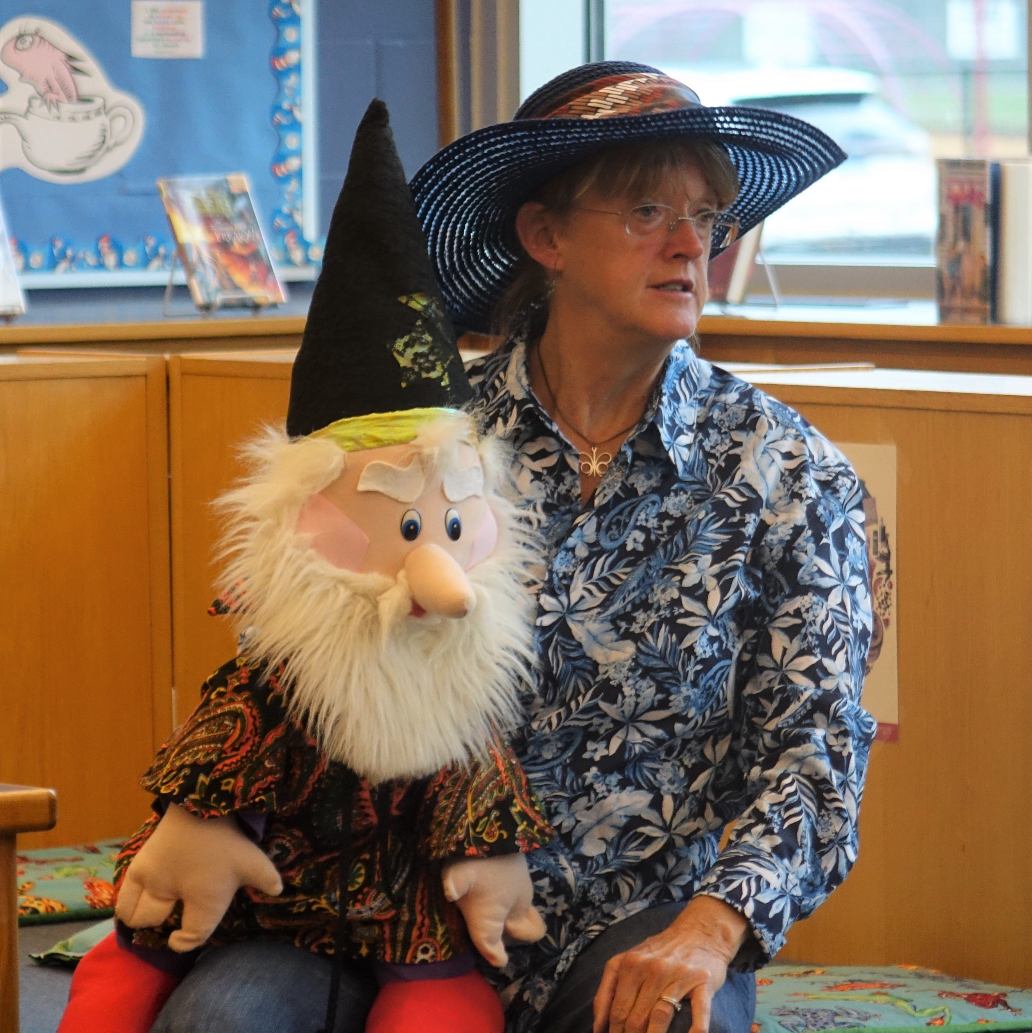
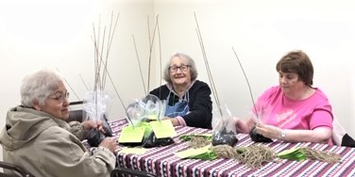

Mrs. Gregory, former Coordinator of the Plainwell SAFE Program and Plainwell Corner's Preschool returns to the school district every year to distribute trees. Ms. Kelly Koehrn, 3rd grade teacher at Gilkey, treasures the tree that was given to her in 1986. It was originally planted at her home on North Main Street, moved to a new home in the country in the early 2000’s, was hit by lightning and still growing today in that yard. “My tree has always been special to me and even more so now because as a 3rd grade teacher at Gilkey, I get to be part of passing on my story to the third graders each year when your garden club so generously continues this tradition.”
Submitted by Karla Labby
Chula Vista Secretary & Publicity Chairperson
April 30, 2019

Kalamazoo in Bloom celebrates its 35 year 1984-2019
We celebrate the 35th year of bring our communities into bloom once again. Colorful flowers and lovable topiaries in the parks of Kalamazoo and Portage enhance our quality of life. We are grateful to all those who came before us and those who continue to help us make this transformation each spring.
- KI B founder, Gale Arent and all board members who have provided the vision and talent that guides us even today.
- Local Greenhouses support us and showcase their annual flowers.
- Cities of Kalamazoo, Portage and Comstock assist in partnership to create our beautiful public spaces.
- Donors and contributors like the Kalamazoo Garden Council and its member gardeners invest in the organization to keep it blooming.
- Our Gardeners and staff’s planning, organization and expertise enable others to enjoy the amazing planting days.
- Volunteers and those who adopt and care for the flower beds throughout the season keep the gardens in the peak of beauty.
Submitted by Mary Van Tassel. KIB Rep 269-375-1708

Join us for the 57th MGC Flower Show Judges Symposium to be held at the Delta Hotel by Marriott in Kalamazoo, MI.

Instructors: Claudia Chopp and Judy Newman will be our design and horticulture instructors, respectively. We will be studying dahlia and succulents for Horticulture and the allied topic will be Writing Constructive Comments. The design subjects will be Group Mass and Cascade, plus Claudia will talk about all the new designs. The Design allied subject will be Techniques. Please join us for this educational event.
Don’t miss this event if you need to refresh your flower show judge credentials for 2019, 2020 or 2021. If you are interested in flower arranging, you may attend as a guest for a fee which is listed in the brochure.

Sharon Yantis,MGC FS Symposium Chair
Norma Stancati,Local Symposium Chair
Lynn Dinvald, Registrar and Treasurer
Hosted by the Lakeshore Flower Arrangers Guild
Click here for the registration brochure

Next Issue:  November 1, 2019  Copy Deadline:  October 1, 2019 |  | For Sale  37 inch screen with remote  Contact Brenda Carl  carlbrenda3@gmail.com

WE ARE ALL AMERICANS (veterans memorials)
The tears were in his voice and in his eyes
As he spoke of those who live
Beneath the bloodied soil of Gettysburg
And all the battlegrounds
Where brother fought brother,
And sometimes father against son.
"It breaks my heart to lose such gallant men,
Some just barely old enough to fight
The drummer boys and buglers
Are barely big enough to march,
Yet they keep up with the big ones,
Not to be left behind."
His sad and somber visage
Looked at all the people there
Wishing to communicate everything he felt
His weariness was evident
As his broad shoulders slumped
Giving evidence of both his pride and sorrow.
To all the men and women who have served and continue to serve!
Marilyn Hartley-Kik
Penned by Alice Hartley
From the book One Day I was Thinking About

Our website has valuable and informative information.
If you haven't already registered visit: KalamazooGardenCouncil.org

Please add KalamazooGardenCouncil@gmail.com to your contacts

